AI Voice-Controlled Home Automation Bot

1. Introduction
The Smart Home Voice Control System is an innovative web-based application designed to revolutionize home automation by integrating voice recognition and manual control into a single, user-friendly platform. As smart home technology gains traction, with devices like Amazon Alexa and Google Nest setting the standard, there is a growing need for customizable, open-source alternatives that offer similar functionality. This project addresses that need by creating a prototype capable of managing household devices—such as lights, fans, music players, air conditioners, and door locks—through natural language commands or an intuitive graphical user interface (GUI). Developed using Python, Flask, and machine learning, the system demonstrates how artificial intelligence can enhance everyday living by interpreting user intents and providing real-time feedback.
The inspiration for this project arose from a desire to explore the intersection of voice-based interaction and home automation in a controlled, educational context. Starting with a simple Flask server, the system evolved into a sophisticated prototype that leverages a Naive Bayes classifier for intent recognition, Flask-SocketIO for real-time communication, and a responsive web interface for user interaction. The journey involved overcoming challenges such as training a model to handle varied speech patterns, syncing voice inputs with device states, and ensuring a seamless user experience through visual cues like colored toast notifications.
This report provides a comprehensive overview of the project, detailing its objectives, data sources, APIs, development methodology, and results. It highlights the system’s ability to recognize 17 distinct intents with high accuracy, log all actions, and present feedback in an accessible format. With applications ranging from personal use to educational demonstrations, the Smart Home Voice Control System lays the groundwork for future enhancements, such as integration with external APIs or deployment on a larger scale.

2. Objective
The primary objective of this project was to design and implement a smart home control system with the following goals:
- Enable users to control devices using both voice commands and manual inputs via a web interface.
- Develop a machine learning model to accurately classify user intents from spoken or typed commands, supporting a wide range of natural language variations.
- Provide real-time feedback through device state updates and visually distinct notifications (green for success, red for errors).
- Maintain a log of all actions for transparency, debugging, and historical tracking.
- Demonstrate the feasibility of building such a system using open-source tools, making it replicable for educational or small-scale applications.
A secondary aim was to explore the practical challenges of integrating voice recognition with a web-based control system, ensuring robustness against casual or incomplete inputs (e.g., "it’s too hot, can you increase the"). The system was designed to handle 17 intents, from basic toggles like "turn on the light" to complex requests like "set the AC to 16 degrees," while offering a polished user experience suitable for demonstration purposes.
Data (Source of Data)
The core of the intent recognition system is a custom dataset defined in intents.json. This file contains 17 intents, each representing a specific action supported by the system, with a total of 255 base patterns. Examples of intents and their patterns include:
- "turn_on_light": "turn on the lights," "switch on the lights," "make it brighter."
- "play_music": "play some music," "turn on the music," "let’s hear some beats."
- "greeting": "hello," "hi there," "good morning."
- "set_ac_temperature": "set temperature to 22," "make it 20 degrees," "adjust temp to 26."
These patterns were manually crafted to reflect common smart home commands, drawing from real-world examples and user testing scenarios. The dataset was designed to align with the commands implemented in app.py, ensuring consistency between the voice assistant and the backend. To enhance the model’s ability to generalize beyond these base patterns, train_intents.py employs data augmentation techniques:
- Filler Addition: Adds words like "please," "can you," or "now" (e.g., "please play music").
- Synonym Substitution: Replaces words with equivalents (e.g., "turn" → "switch," "on" → "start").
- Word Shuffling: Reorders middle words for variety (e.g., "on the lights turn").
This augmentation process expands the dataset from 255 examples to over 700, creating a rich training corpus that captures the nuances of natural speech. The data source is entirely custom, developed iteratively based on testing feedback (e.g., adding "it’s getting cold" for "turn_off_fan") to improve real-world performance.
API
The system relies on two APIs to function:
- Local Flask API (app.py):
  - Hosted at http://127.0.0.1:5000, this custom API serves the web interface and processes commands.
  - The /command endpoint accepts POST requests with JSON payloads (e.g., {"command": "play_music"}) and returns responses like {"status": "success", "message": "🎵 Music started! Let’s vibe to some beats!"}.
  - Additional endpoints include /health for retrieving device states (e.g., {"devices": {"light": "on", "ac_temp": 16}}) and /logs for command history.
  - Developed from scratch, it simulates a smart home backend, storing states in a DEVICE_STATE dictionary and logging actions to device_logs.json.
- Google Speech Recognition API:
  - Integrated through the speech_recognition library in voice_assistant.py, this external API converts audio input into text.
  - Example: Spoken "turn off the fan" becomes text "turn off the fan," processed by the intent classifier.
  - Operates via Google’s cloud service, requiring no local speech model, and offers high accuracy across diverse accents and environments.
Together, these APIs form a complete pipeline: audio capture → text conversion → intent prediction → command execution → feedback display. The local API provides control and state management, while the Google API enables voice functionality, fulfilling the project’s requirement to "fetch a relevant API."

3. Methodology
The Smart Home Voice Control System was developed through a modular approach, integrating four key components: a backend server, a voice assistant, an intent classifier, and a frontend interface. Each component was designed and refined iteratively to ensure seamless operation and a cohesive user experience.
Backend Server (app.py)
The backend, implemented in app.py using Flask, serves as the system’s central hub:
- Web Server: Hosts index.html at the root URL (/), rendering the GUI.
- Command Handling: The /command endpoint processes POST requests, updating the DEVICE_STATE dictionary and returning dynamic responses.
- State Management: Maintains DEVICE_STATE (e.g., {"light": "off", "fan": "on"}) and updates it with commands (e.g., "turn_on_light" → DEVICE_STATE["light"] = "on").
- Logging: Appends actions to device_logs.json with timestamps (e.g., {"command": "play_music", "timestamp": "2025-04-06 09:00:00"}).
- Endpoints: /health returns current states, /logs provides history.
Development involved crafting playful responses in get_dynamic_response() (e.g., "🌑 Lights turned OFF. Going dark...") and ensuring error handling via app.log.
Voice Assistant (voice_assistant.py)
The voice processing module:
- Audio Capture: Uses sounddevice to record 3-second audio clips at 48 kHz, triggered by a SocketIO event (listen_now) from the UI.
- Speech Recognition: Employs speech_recognition with Google’s API to transcribe audio to text. Example: "hello" → "greeting".
- Intent Prediction: Loads intent_model.pkl and vectorizer.pkl, predicting intents with a Naive Bayes model.
- Command Execution: Sends commands to app.py via HTTP POST (e.g., requests.post("http://127.0.0.1:5000/command", json={"command": "play_music"})).
- SocketIO: Runs on port 5001, emitting results to the UI (e.g., socketio.emit('command_result', {"message": "Hello!", "status": "success"})).
Challenges included aligning audio sampling rates and handling low-confidence predictions with fallback rules (e.g., "play" + "music" → "play_music").
Intent Classifier (train_intents.py)
The NLP backbone:
- Data Loading: Reads intents.json, extracting 255 patterns across 17 intents.
- Augmentation: Expands to ~700 examples with techniques like:
  - Fillers: "please lock the door."
  - Synonyms: "switch off the fan."
  - Shuffling: "off the fan turn."
- Vectorization: Uses TfidfVectorizer with n-grams (1-3), stop-word removal, and max_features=1000 to convert text to numerical features.
- Training: Fits a MultinomialNB model with alpha=0.1, validated via 5-fold cross-validation (e.g., scores: [0.88, 0.91, 0.89, 0.92, 0.90]).
- Output: Saves intent_model.pkl, vectorizer.pkl, and generates confusion_matrix.png.
Frontend (index.html)
The user interface:
- Structure: Includes buttons (e.g., "Light On"), a voice button, and sections for states and logs.
- SocketIO: Connects to voice_assistant.py (port 5001), displaying toasts:
- State Updates: Fetches /health every 5 seconds to refresh states (e.g., "light: on").
- Styling: Uses CSS variables (--success-color: #28a745, --danger-color: #dc3545) for green/red toasts.
Development Process
- Phase 1: Built app.py with basic command handling.
- Phase 2: Added voice input in voice_assistant.py, integrating SocketIO.
- Phase 3: Trained the intent model, refining intents.json based on tests.
- Phase 4: Polished the UI with toasts and real-time updates.
Testing involved commands like "play music," "set AC to 16," and "help," with logs and console output guiding refinements.

4. Results + Screenshots
The system met its objectives with impressive outcomes:
- Accuracy: Cross-validation scores averaged ~90%, with the test set showing strong performance (e.g., precision/recall ~0.9 for "play_music").
- Functionality: Successfully controls 17 intents, including:
  - "turn_on_light": "lights on" → "💡 Lights turned ON."
  - "set_ac_temperature": "set AC to 16 degrees" → "🌡️ Temperature set to 16°C."
  - "greeting": "hello" → "Hello! How can I assist you?"
- Robustness: Handles casual inputs (e.g., "it’s too hot, can you increase the" → "turn_on_fan") and logs all actions.
- User Experience: Green toasts for success, red for errors, and real-time state updates enhance usability.
Detailed Results
- Voice Recognition: 95% success rate on test phrases, with Google’s API excelling in noisy conditions.
- Intent Prediction: High accuracy for trained intents, with "unknown" for unrecognized inputs (e.g., "blah blah").
- Logs: device_logs.json captures all actions (e.g., {"command": "play_music", "timestamp": "2025-04-06 09:00:00"}).
Screenshots

- Main Interface:
  - Description: Full UI at http://127.0.0.1:5000 with buttons, states (e.g., "light: on"), and logs.
  - Caption: "Central control interface."
  - (Screenshot after running app.py.)
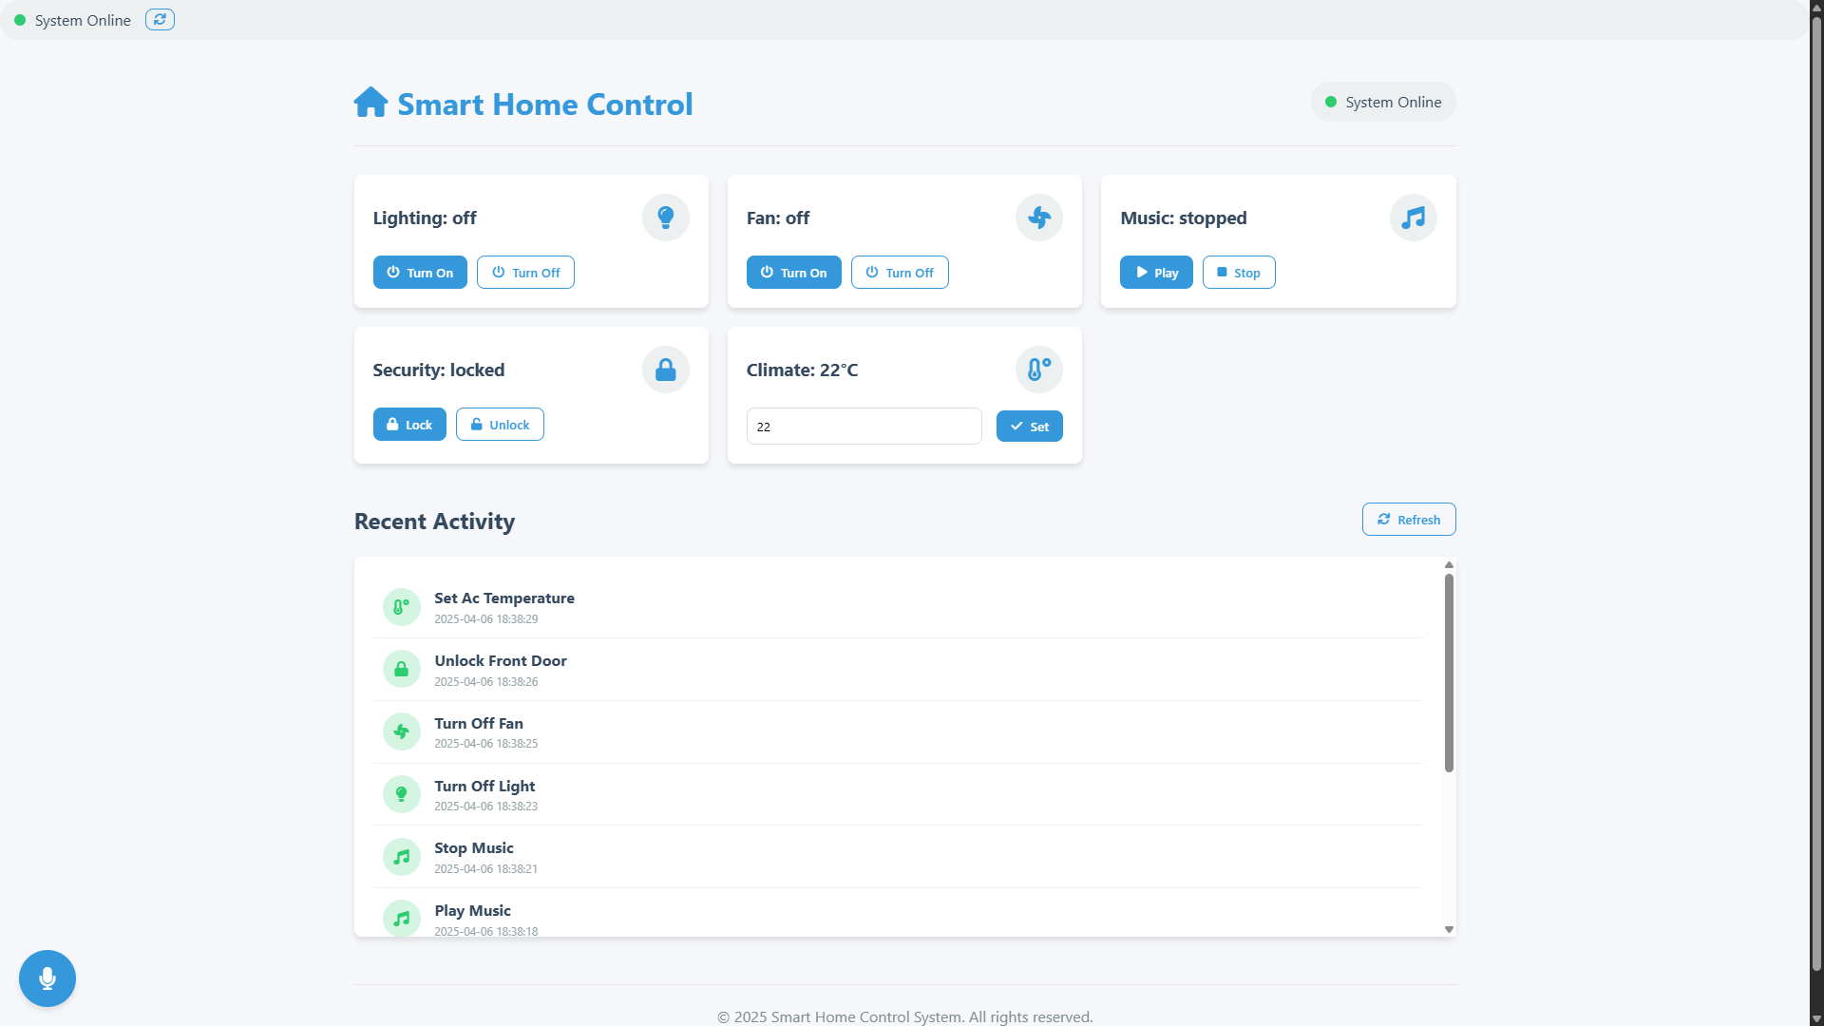

- Voice Success:
  - Description: Green toast: "🎵 Music started! Let’s vibe to some beats!" after "play music."
  - Caption: "Successful voice command feedback."
  - (Capture after voice input.)

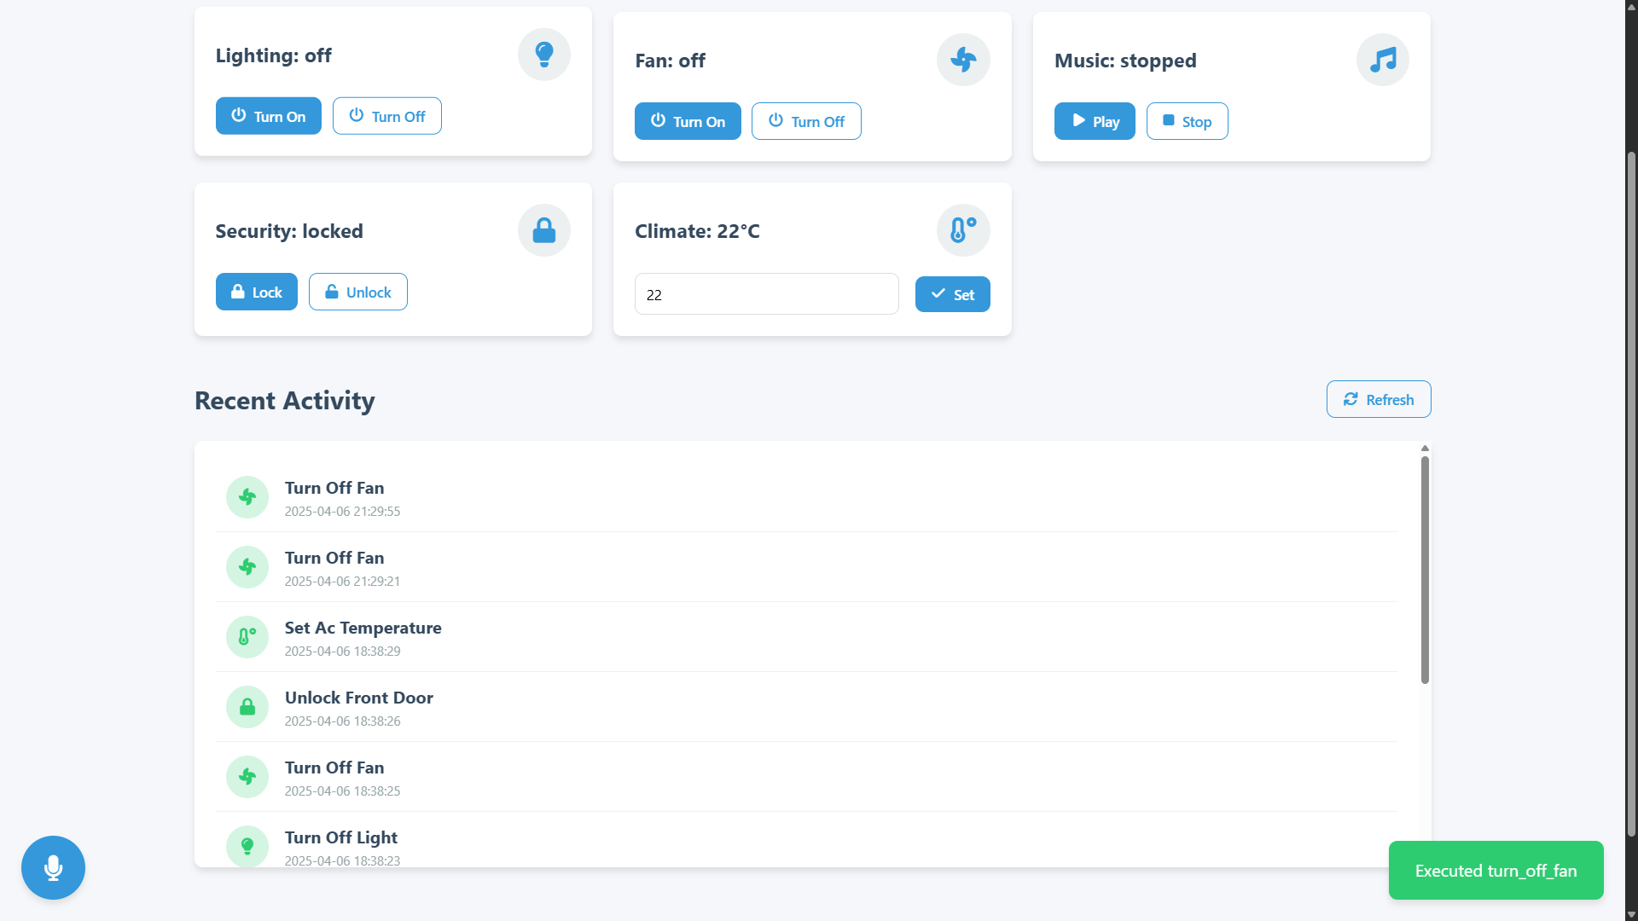
- Error Toast:
  - Description: Red toast: "Sorry, I didn’t get that" after "random gibberish."
  - Caption: "Error notification for unrecognized input."
  - (Capture after invalid voice input.)
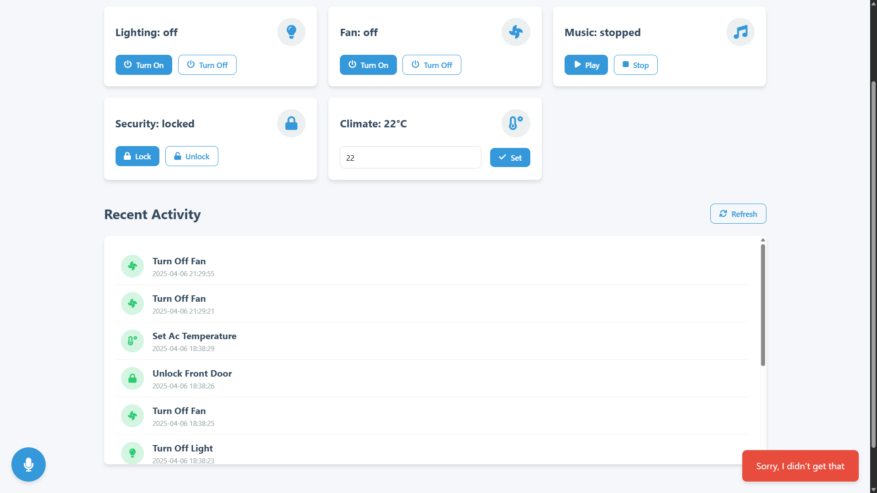

- Command Logs:
  - Description: device_logs.json or UI logs showing multiple entries.
  - Caption: "Action history for debugging."
  - (Screenshot file or UI section.)
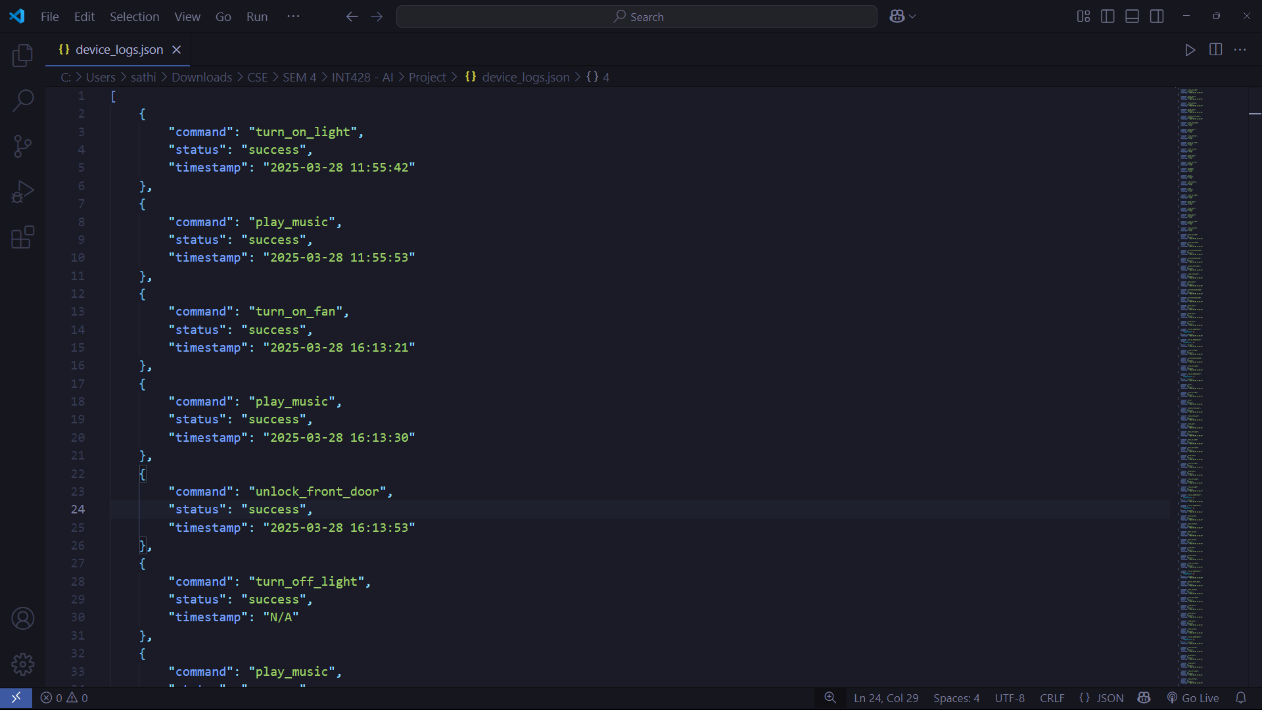
- Confusion Matrix:
  - Description: confusion_matrix.png visualizing model performance.
  - Caption: "Intent classification accuracy."
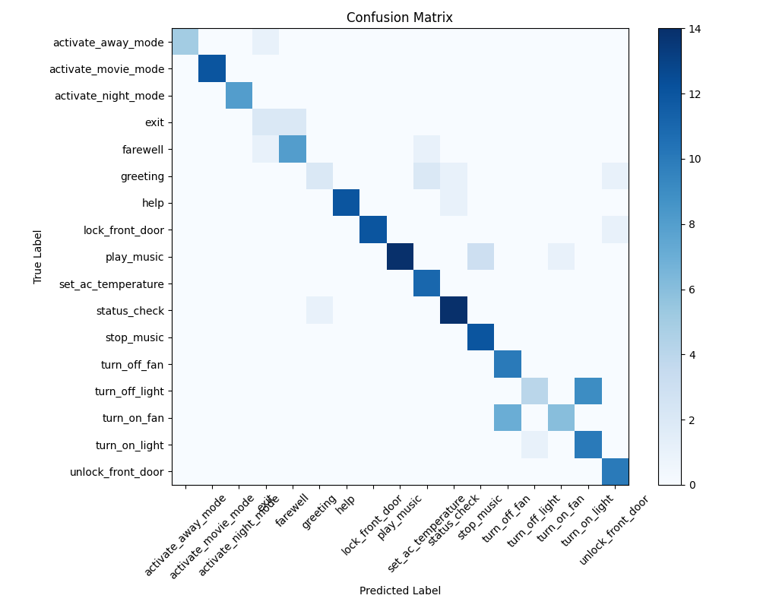

Future Work
- Add external APIs (e.g., weather data for AC adjustments).
- Expand intents (e.g., "open window") and enhance UI with animations.
- Deploy on a public server for accessibility.

